Community HealthChoices Resources
Table of Contents
Department of Human Services 1
Department of Human Services (DHS) 1
Community HealthChoices (CHC) 1
CHC for Providers 1
CHC for Participants 1
Participant Call Center 1
Provider Call Center 1
PA Relay 1
CHC Fact Sheet 1
Adult Benefits Package 1
Information on Electronic Visit Verification (EVV) system 1
Information about Cost of Care – OIM Long-Term Care Handbook Chapter 468: 468.3 Payment Toward the Cost of LTC Facility Services- Step 2 1
MLTSS Subcommittee 2
NHT Helpline 2
Managed Care Organizations 3
AmeriHealth Caritas Pennsylvania (Keystone First in the Southeast) 3
Keystone First 3
PA Health & Wellness 3
UPMC Community HealthChoices 3
PA Independent Enrollment Broker 4
ListServs, Forms, Bulletins, Alternatives to Nursing Homes, and Quick Tips 5
ListServs 5
Department of Human Services List Archives 6
DHS Form Search 8
Bulletin Search 9
Alternatives to Nursing Homes (HCBS Waiver Services) 10
Quick Tips for Medicaid Providers 11

Department of Human Services

Department of Human Services (DHS)
https://www.pa.gov/en/agencies/dhs.html

Community HealthChoices (CHC)
https://www.pa.gov/en/agencies/dhs/resources/medicaid/chc.html

CHC for Providers
https://www.pa.gov/en/agencies/dhs/resources/medicaid/chc/chc-providers.html

CHC for Participants
https://www.pa.gov/en/agencies/dhs/resources/medicaid/chc.html

Participant Call Center
800-757-5042

Provider Call Center
800-938-0939

PA Relay
Dial 711

CHC Fact Sheet
https://www.pa.gov/content/dam/copapwp-pagov/en/dhs/documents/healthchoices/hc-services/documents/CHC%20Fact%20Sheet.pdf

Adult Benefits Package
https://www.pa.gov/content/dam/copapwp-pagov/en/dhs/documents/healthchoices/hc-services/documents/Adults%20Benefits%20Package.pdf

Information on Electronic Visit Verification (EVV) system
https://www.pa.gov/en/agencies/dhs/resources/for-providers/evv.html

Information about Cost of Care – OIM Long-Term Care Handbook Chapter 468: 468.3 Payment Toward the Cost of LTC Facility Services- Step 2
http://services.dpw.state.pa.us/oimpolicymanuals/ltc/index.htm#t=468_Eligibility_and_Payment%2F468_3_Step2_Pmt_toward_LTC_Facility_Srvs.htm

Medical Assistance Advisory Committee (MAAC)
https://www.pa.gov/en/agencies/dhs/about/councils-committees/maac.html

MLTSS Subcommittee
https://www.pa.gov/en/agencies/dhs/about/councils-committees/managed-long-term-subcommittee.html

NHT Helpline
800-833-5196

Managed Care Organizations

AmeriHealth Caritas Pennsylvania (Keystone First in the Southeast)
https://www.amerihealthcaritaschc.com/
Participant Services: 1-855-235-5115 (TTY 1-800-235-5112)
Provider Services: 1-800-521-6007
LTSS provider email: chcproviders@amerihealthcaritas.com

Keystone First
https://www.keystonefirstchc.com/index.aspx
Participant Services: 1-855-332-0729 (TTY 1-855-235-4976)
Provider Services: 1-800-521-6007
Email: Long-term Services and Supports (LTSS) Providers: chcproviders@keystonefirstchc.com

PA Health & Wellness
https://www.pahealthwellness.com/
Phone: 1-844-626-6813 (TTY 711)
Submit inquiries through this contact form (https://www.pahealthwellness.com/contact-us.html)

UPMC Community HealthChoices
https://chc.upmchealthplan.com/
Participant Services: 1-844-833-0523 (TTY 711)
Email: chc@upmc.edu

PA Independent Enrollment Broker
https://paieb.com/en
- On this webpage you can select “Apply” to apply for Long Term Services and Supports (LTSS) Waiver services.
- On this webpage you can select “Contact us” and then select “referral form” to apply for Home and Community Based Services or to contact the PA Independent Enrollment Broker.

By telephone
Call the PA IEB Helpline at 1-844-824-3655 (TTY: 711)
We are open Monday through Friday, 8:00 a.m. to 6:00 p.m.

By Mail
PA IEB
P.O. Box 61560
Harrisburg PA 17106

ListServs, Forms, Bulletins, Alternatives to Nursing Homes, and Quick Tips

ListServs
Documents are issued through the program office ListServ and posted to state websites.
The DHS listServs can be accessed through the Online Services page at https://www.pa.gov/en/agencies/dhs/contact/newsletters-listservs.html.

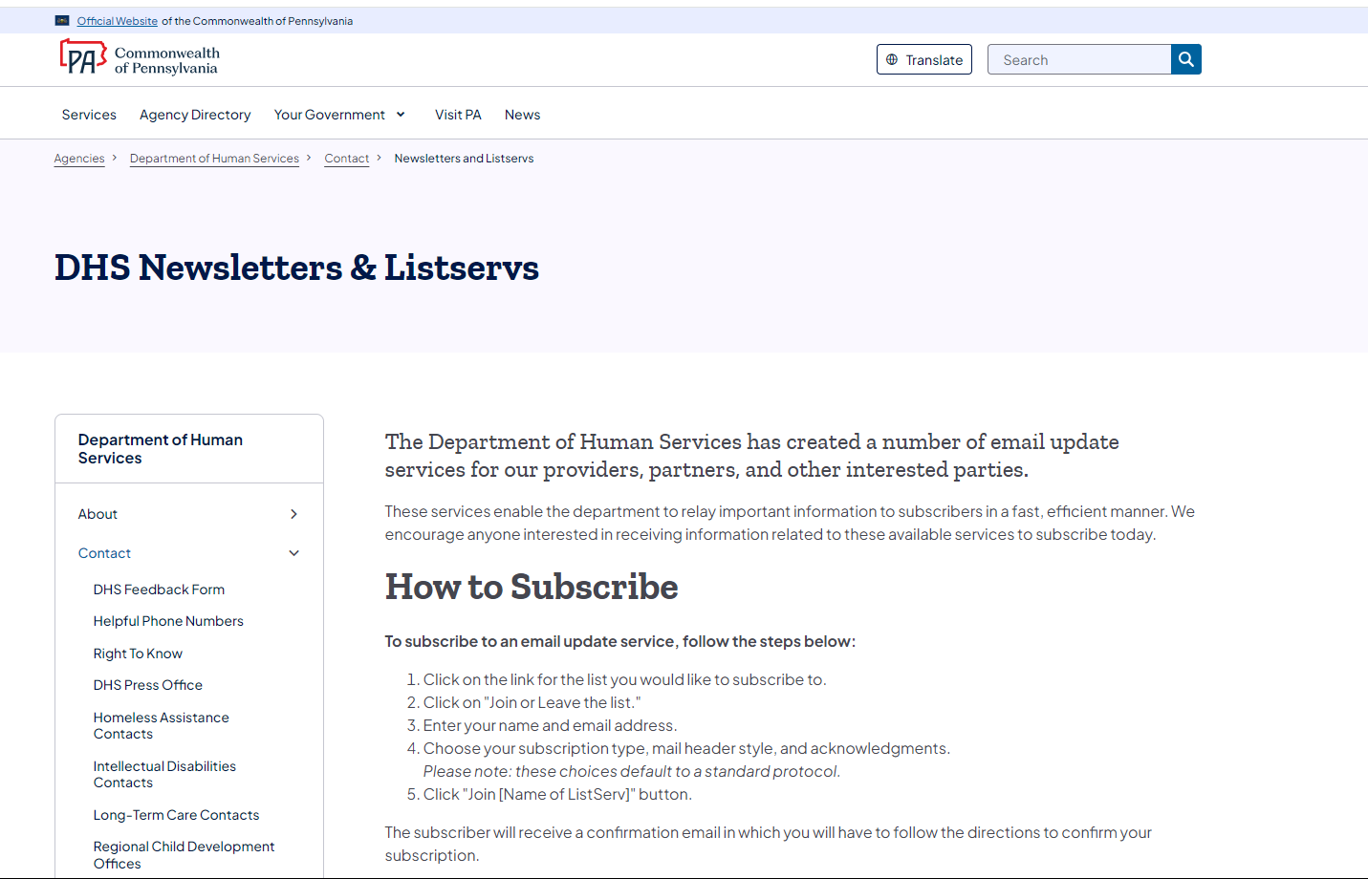

Department of Human Services List Archives
http://listserv.dhs.pa.gov/
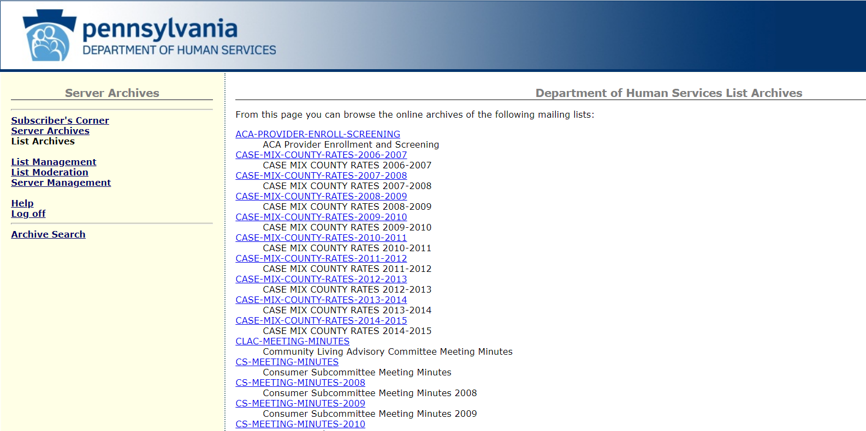

MLTSS-MEETING-MINUTES
http://listserv.dhs.pa.gov/mltss-meeting-minutes.html
Managed Long Term Services and Supports Subcommittee

OLTL-COMMUNITY-HEALTHCHOICES
http://listserv.dhs.pa.gov/oltl-community-healthchoices.html
OLTL Community HealthChoices

OLTL-SERVICE-COORDINATORS
http://listserv.dhs.pa.gov/oltl-service-coordinators.html
OLTL Service Coordinators

OLTL-PA-LIFE-PRVDRS
http://listserv.dhs.pa.gov/oltl-pa-life-prvdrs.html
OLTL PA Life Providers

HOME-COMMUNITY-WAIVER-PRVDRS
http://listserv.dhs.pa.gov/home-community-waiver-prvdrs.html
OLTL Home Community Waiver Providers

OLTL-NURSING-FACILITIES
http://listserv.dhs.pa.gov/oltl-nursing-facilities.html
OLTL Nursing Facilities

DHS-STAKEHOLDERS
http://listserv.dhs.pa.gov/dhs-stakeholders.html
DHS Stakeholders

After you select the ListServ, click on the second bullet point, “Join or leave the list (or change settings).” Then enter your name, email address and click the Subscribe button. You will receive an email asking you to confirm the registration. You must confirm to be successfully registered for the ListServ.

DHS Form Search
https://www.pa.gov/en/agencies/dhs/resources/for-providers/form-search.html
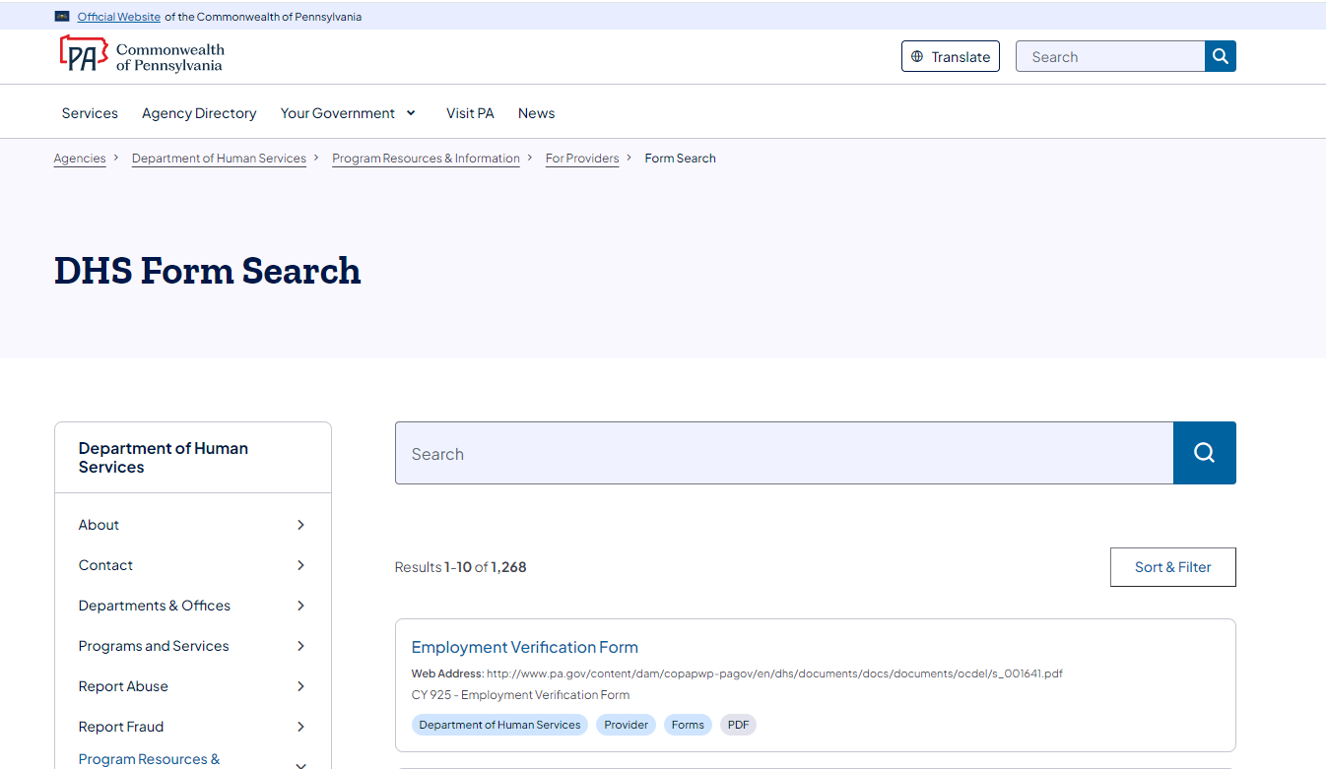
2

Bulletin Search
www.pa.gov/en/agencies/dhs/resources/for-providers/bulletin-search.html#sortCriteria=%40copapwpdate%20descending
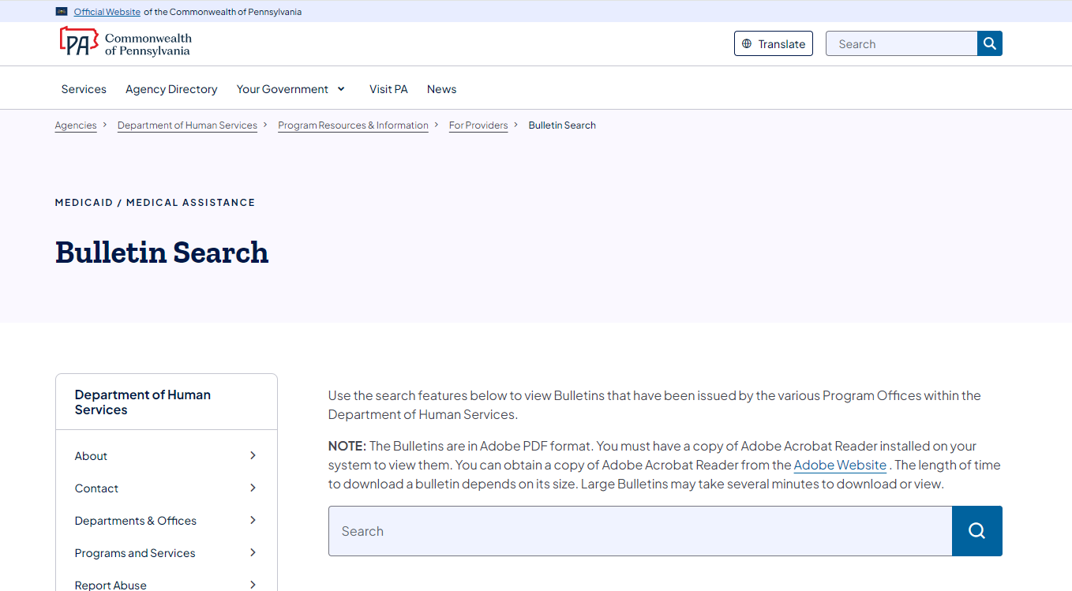

Alternatives to Nursing Homes (HCBS Waiver Services)
https://www.pa.gov/en/agencies/dhs/resources/aging-physical-disabilities/alternatives-to-nursing-homes.html
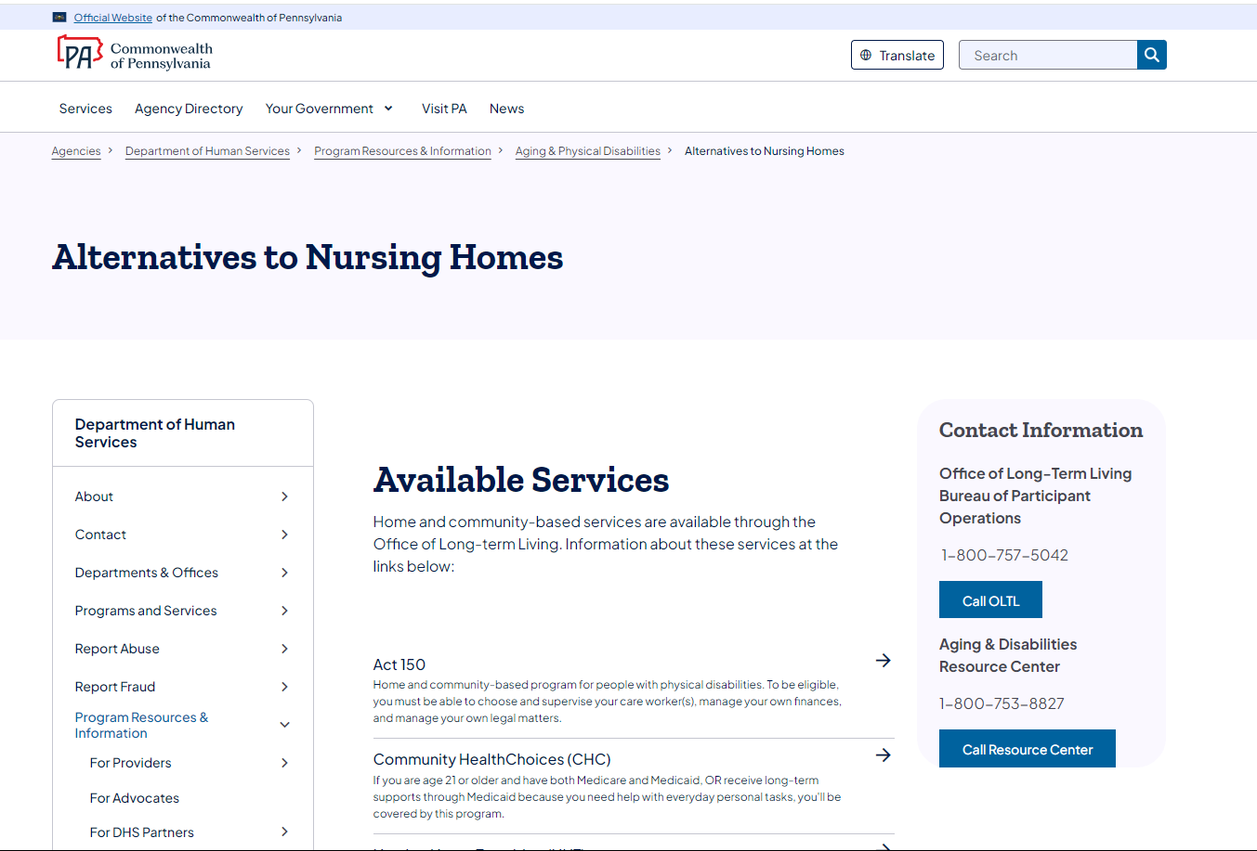

Quick Tips for Medicaid Providers
https://www.pa.gov/en/agencies/dhs/resources/for-providers/providers-quick-tips.html

