Provider Resources

Table of Contents
Module 1: Introduction to Long-term Care 1
Bureau of Fee-for-Service Programs 1
Community HealthChoices Provider Resources 1
Independent Enrollment Broker (IEB) 1
IEB Helpline 1
OLTL Participant Helpline 1
Participant Information Packet 1
PA Link to Aging and Disability Resources 1
Provider Enrollment Information 2
Waiver Descriptions 2
Module 2: Provider Responsibilities 2
DHS Training for Providers 2
Incident Management and Protective Services Online Training 2
Electronic Visit Verification 2
MA Bulletin 99-11-05 2
Pa Code 2
55 Pa Code § 52.20 2
55 Pa Code § 52.25 2
PROMISe Provider Education and Training 2
American Translators Association 2
Registry of Interpreters for the Deaf 3
PA Relay Services 3
DHS ListServs 4
Bulletin Search 5
Publications Search 6
DHS Form Search 7

Module 1: Introduction to Long-term Care

Bureau of Fee-for-Service Programs
https://www.pa.gov/en/agencies/dhs/departments-offices/omap-info/omap-bureau-fee-for-services-programs.html
Office of Long-Term Living (OLTL) Provider Call Center
Toll free: 1-800-932-0939
Mon – Thurs, 9:00 am to 12:00 pm and 1:00 pm to 4:00 pm
Option 1: Provider Enrollment
Option 2: Billing and Claims
Option 3: Nursing Home Transition
Email for billing and claims: RA-ProviderOperation@pa.gov
Email Enrollment section: RA-HCBSEnProv@pa.gov
Fax: (717) 772-0965

Community HealthChoices Provider Resources
https://www.pa.gov/en/agencies/dhs/resources/medicaid/chc/chc-providers.html

Independent Enrollment Broker (IEB)
https://www.pa.gov/en/agencies/dhs/resources/aging-physical-disabilities/independent-enrollment-broker.html

IEB Helpline
Toll Free: 1-877-550-4227

OLTL Participant Helpline
Toll Free: 1-800-757-5042

Participant Information Packet
https://www.pa.gov/content/dam/copapwp-pagov/en/dhs/documents/services/disabilities-aging/documents/long-term-care-services/Participant%20Information%20Packet.pdf
The Participant Information Packet is available in several languages on the Long-Term Care Services webpage.
https://www.pa.gov/en/agencies/dhs/resources/aging-physical-disabilities/long-term-care-services.html

PA Link to Aging and Disability Resources
https://www.pa.gov/en/agencies/aging/local-resources/pa-link-to-aging-and-disability-resources.html
Toll free: 1-800-753-8827

Provider Enrollment Information
https://www.pa.gov/agencies/dhs/resources/for-providers/provider-enrollment-information

Waiver Descriptions
https://www.pa.gov/en/agencies/dhs/resources/medicaid/waivers.html

Module 2: Provider Responsibilities

DHS Training for Providers
https://www.pa.gov/en/agencies/dhs/resources/for-providers/provider-trainings.html

Incident Management and Protective Services Online Training
https://oltl-provider.deringconsulting.com/

Electronic Visit Verification
https://www.pa.gov/en/agencies/dhs/resources/for-providers/evv.html

MA Bulletin 99-11-05
Provider Screening of Employees and Contractors for Exclusion from Participation in Federal Health Care Programs and the Effect of Exclusion on Participation
https://www.pa.gov/content/dam/copapwp-pagov/en/dhs/documents/docs/publications/documents/forms-and-pubs-omap/d_005732.pdf

Pa Code
https://www.pacodeandbulletin.gov/

55 Pa Code § 52.20
http://www.pacodeandbulletin.gov/Display/pacode?file=/secure/pacode/data/055/chapter52/chap52toc.html&d=#52.20

55 Pa Code § 52.25
http://www.pacodeandbulletin.gov/Display/pacode?file=/secure/pacode/data/055/chapter52/chap52toc.html&d=#52.25.

PROMISe Provider Education and Training
https://www.pa.gov/en/agencies/dhs/resources/for-providers/promise/promise-provider-training.html

American Translators Association
https://www.atanet.org/

Registry of Interpreters for the Deaf
https://www.rid.org/

PA Relay Services
https://www.puc.pa.gov/telecommunications/telecommunications-relay-service/pa-relay-services/

DHS ListServs
https://www.pa.gov/en/agencies/dhs/contact/newsletters-listservs.html
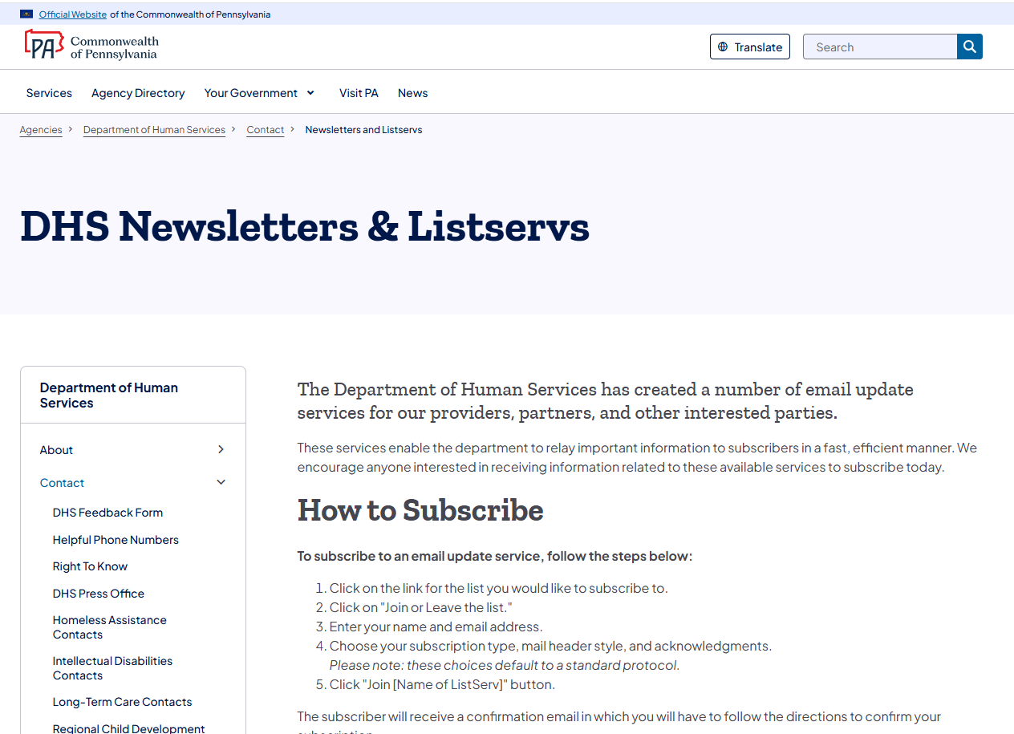

Bulletin Search
https://www.pa.gov/en/agencies/dhs/resources/for-providers/bulletin-search.html#sortCriteria=%40copapwpissuedate%20descending
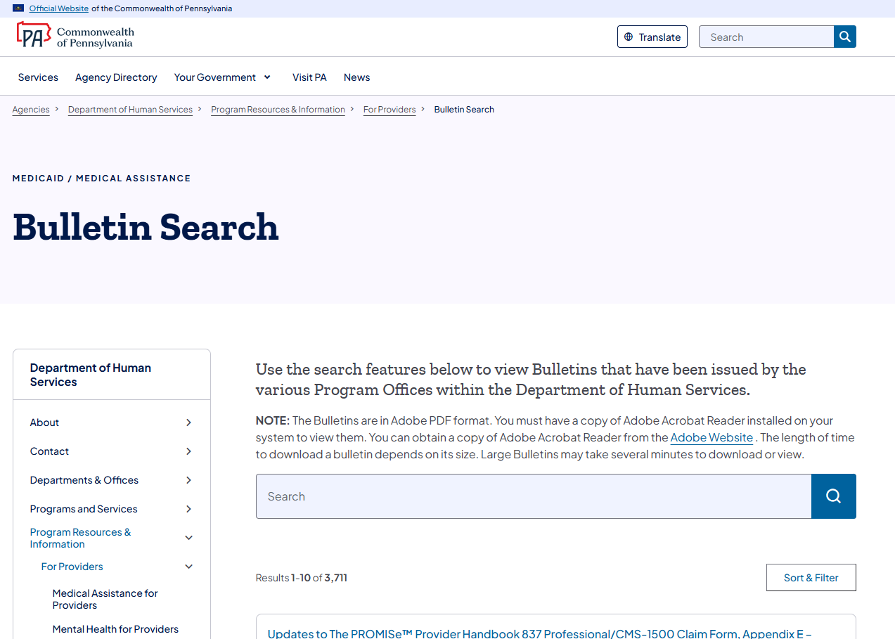

Publications Search
https://www.pa.gov/en/agencies/dhs/dhs-search/dhs-publications.html
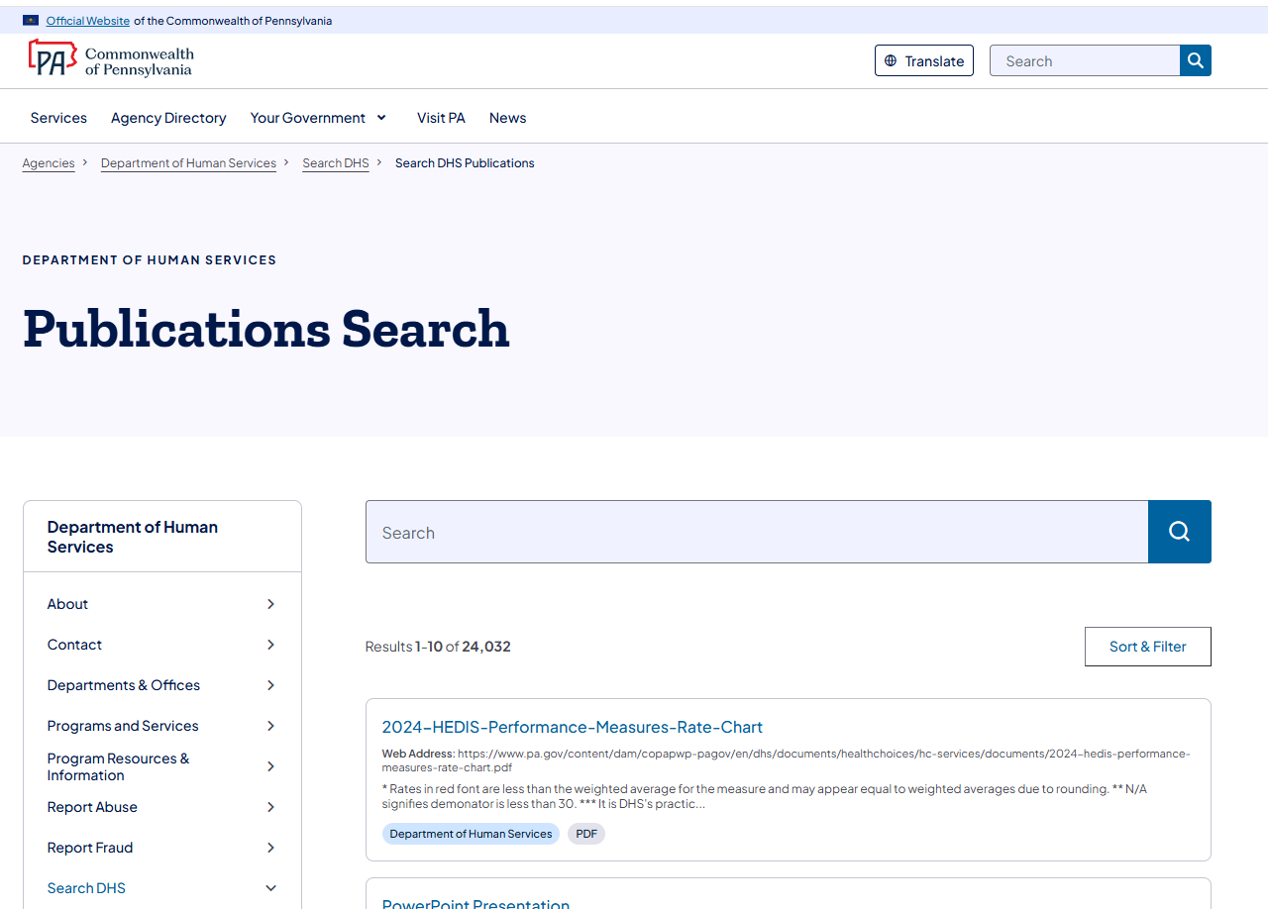

DHS Form Search
https://www.pa.gov/en/agencies/dhs/resources/for-providers/form-search.html
