Provider Resources

Table of Contents

Module 1: Introduction to Long-term Care 1

Bureau of Fee-for-Service Programs 1

Community HealthChoices Provider Resources 1

Independent Enrollment Broker (IEB) 1

IEB Helpline 1

OLTL Participant Helpline 1

Participant Information Packet 1

PA Link to Aging and Disability Resources 1

Provider Enrollment Information 2

Waiver Descriptions 2

Module 2: Provider Responsibilities 2

DHS Training for Providers 2

Incident Management and Protective Services Online Training 2

Electronic Visit Verification 2

MA Bulletin 99-11-05 2

Pa Code 2

55 Pa Code § 52.20 2

55 Pa Code § 52.25 2

PROMISe Provider Education and Training 2

American Translators Association 3

Registry of Interpreters for the Deaf 3

PA Relay Services 3

DHS ListServs 4

Bulletin Search 5

Publications Search 6

DHS Form Search 7

# Module 1: Introduction to Long-term Care

## [Bureau of Fee-for-Service Programs](https://www.dhs.pa.gov/contact/DHS-Offices/Pages/OMAP-Bureau%20of%20Fee-For-Service%20Programs.aspx)

https://www.pa.gov/en/agencies/dhs/departments-offices/omap-info/omap-bureau-fee-for-services-programs.html

**Office of Long-Term Living (OLTL) Provider Call Center**

**Toll free: 1-800-932-0939**

Mon – Thurs, 9:00 am to 12:00 pm and 1:00 pm to 4:00 pm

Option 1: Provider Enrollment

Option 2: Billing and Claims

Option 3: Nursing Home Transition

Email for billing and claims: [RA-ProviderOperation@pa.gov](mailto:RA-ProviderOperation@pa.gov)

Email Enrollment section: [RA-HCBSEnProv@pa.gov](mailto:RA-HCBSEnProv@pa.gov)

Fax: (717) 772-0965

## [Community HealthChoices Provider Resources](https://www.dhs.pa.gov/HealthChoices/HC-Providers/Pages/CHCProvider-Main.aspx)

https://www.pa.gov/en/agencies/dhs/resources/medicaid/chc/chc-providers.html

## [Independent Enrollment Broker (IEB)](https://www.pa.gov/en/agencies/dhs/resources/aging-physical-disabilities/independent-enrollment-broker.html)

https://www.pa.gov/en/agencies/dhs/resources/aging-physical-disabilities/independent-enrollment-broker.html

## IEB Helpline

Toll Free: 1-877-550-4227

## OLTL Participant Helpline

Toll Free: 1-800-757-5042

## [Participant Information Packet](https://www.pa.gov/content/dam/copapwp-pagov/en/dhs/documents/services/disabilities-aging/documents/long-term-care-services/Participant%20Information%20Packet.pdf)

https://www.pa.gov/content/dam/copapwp-pagov/en/dhs/documents/services/disabilities-aging/documents/long-term-care-services/Participant%20Information%20Packet.pdf

The Participant Information Packet is available in several languages on the [Long-Term Care Services](https://www.dhs.pa.gov/Services/Disabilities-Aging/Pages/Long-Term-Care-Services.aspx) webpage.

https://www.pa.gov/en/agencies/dhs/resources/aging-physical-disabilities/long-term-care-services.html

## [PA Link to Aging and Disability Resources](http://www.aging.pa.gov/local-resources/pa-link/Pages/default.aspx)

https://www.pa.gov/en/agencies/aging/local-resources/pa-link-to-aging-and-disability-resources.html

Toll free: 1-800-753-8827

## [Provider Enrollment Information](https://www.dhs.pa.gov/providers/Providers/Pages/PROMISe-Enrollment.aspx)

https://www.pa.gov/en/agencies/dhs/resources/for-providers/promise/promise-provider-enrollment.html

## [Waiver Descriptions](https://www.pa.gov/en/agencies/dhs/resources/medicaid/waivers.html)

https://www.pa.gov/en/agencies/dhs/resources/medicaid/waivers.html

# Module 2: Provider Responsibilities

## [DHS Training for Providers](https://www.pa.gov/en/agencies/dhs/resources/for-providers/provider-trainings.html)

https://www.pa.gov/en/agencies/dhs/resources/for-providers/provider-trainings.html

## [Incident Management and Protective Services Online Training](https://oltl-provider.deringconsulting.com/)

https://oltl-provider.deringconsulting.com/

## [Electronic Visit Verification](https://www.dhs.pa.gov/providers/Billing-Info/Pages/EVV.aspx)

https://www.pa.gov/en/agencies/dhs/resources/for-providers/evv.html

## [MA Bulletin 99-11-05](https://www.pa.gov/content/dam/copapwp-pagov/en/dhs/documents/docs/publications/documents/forms-and-pubs-omap/d_005732.pdf)

Provider Screening of Employees and Contractors for Exclusion from Participation in Federal Health Care Programs and the Effect of Exclusion on Participation

https://www.pa.gov/content/dam/copapwp-pagov/en/dhs/documents/docs/publications/documents/forms-and-pubs-omap/d_005732.pdf

## [Pa Code](https://www.pacodeandbulletin.gov/)

https://www.pacodeandbulletin.gov/

## [55 Pa Code § 52.20](http://www.pacodeandbulletin.gov/Display/pacode?file=/secure/pacode/data/055/chapter52/chap52toc.html&d=" \l "52.20.)

http://www.pacodeandbulletin.gov/Display/pacode?file=/secure/pacode/data/055/chapter52/chap52toc.html&d=#52.20

## [55 Pa Code § 52.25](http://www.pacodeandbulletin.gov/Display/pacode?file=/secure/pacode/data/055/chapter52/chap52toc.html&d=" \l "52.25.)

http://www.pacodeandbulletin.gov/Display/pacode?file=/secure/pacode/data/055/chapter52/chap52toc.html&d=#52.25.

## [PROMISe Provider Education and Training](https://www.dhs.pa.gov/providers/Providers/Pages/PROMISe-Provider-Education-Training.aspx)

https://www.pa.gov/en/agencies/dhs/resources/for-providers/promise/promise-provider-training.html

## [American Translators Association](https://www.atanet.org/)

https://www.atanet.org/

## [Registry of Interpreters for the Deaf](https://www.rid.org/)

https://www.rid.org/

## [PA Relay Services](http://www.puc.pa.gov/consumer_info/telecommunications/pa_relay_services_.aspx)

https://www.puc.pa.gov/telecommunications/telecommunications-relay-service/pa-relay-services/

# [DHS ListServs](https://www.pa.gov/en/agencies/dhs/contact/newsletters-listservs.html)

https://www.pa.gov/en/agencies/dhs/contact/newsletters-listservs.html

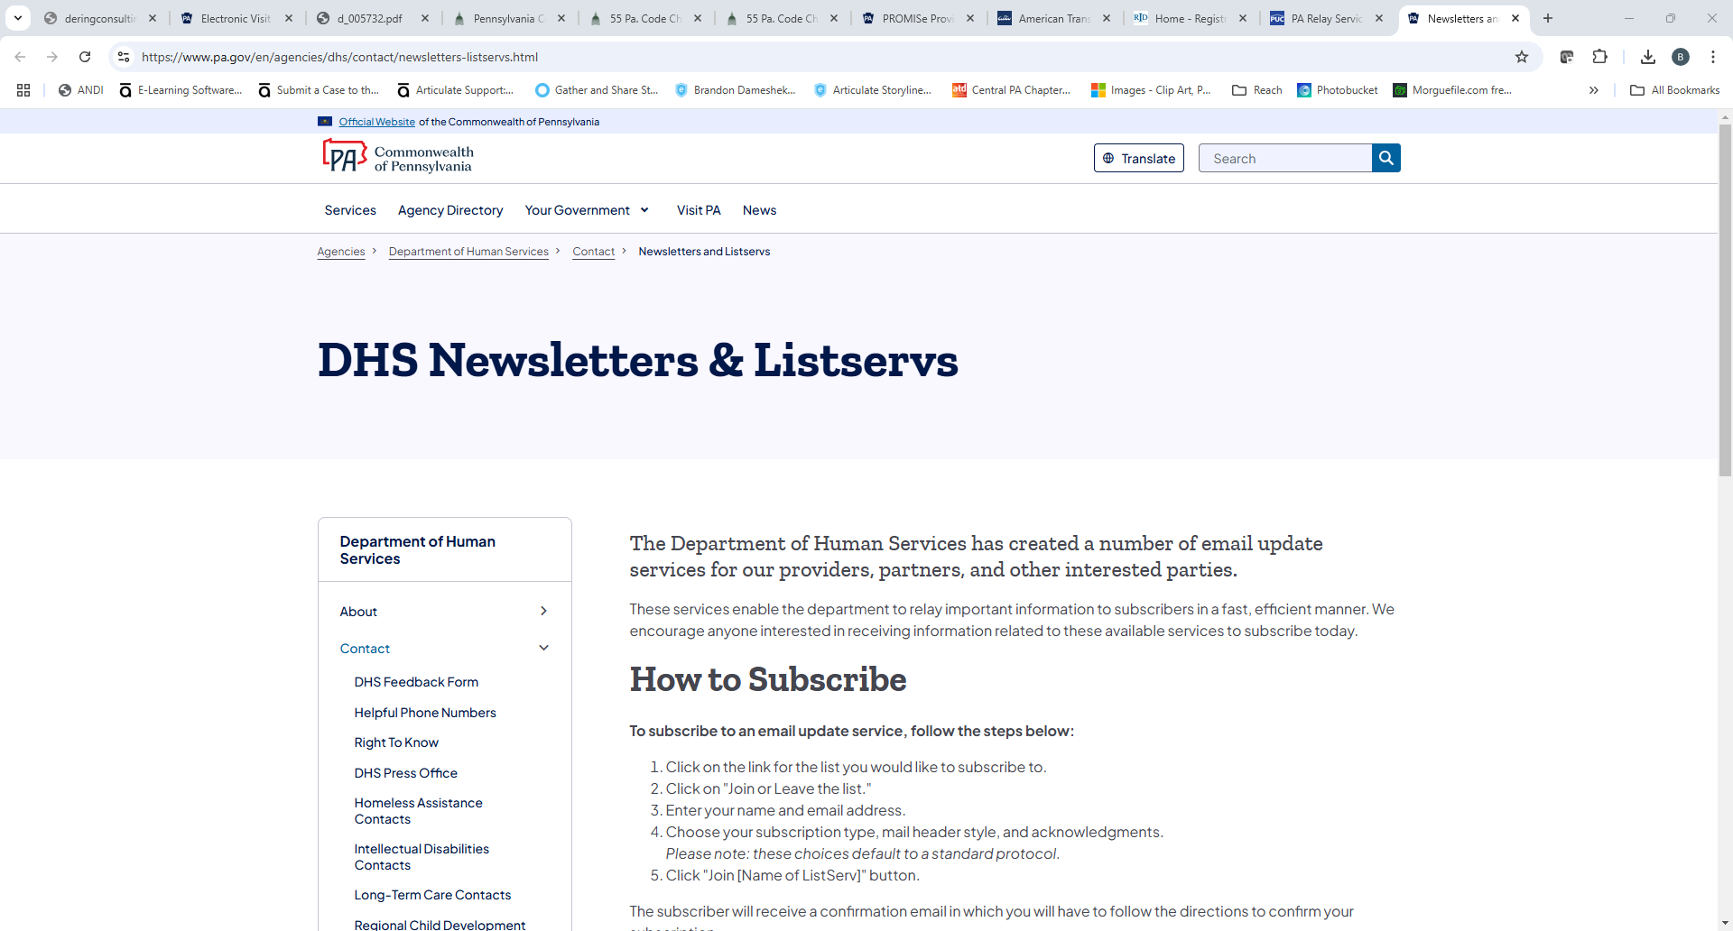

# [Bulletin Search](https://www.pa.gov/en/agencies/dhs/resources/for-providers/bulletin-search.html" \l "sortCriteria=%40copapwpissuedate%20descending)

https://www.pa.gov/en/agencies/dhs/resources/for-providers/bulletin-search.html#sortCriteria=%40copapwpissuedate%20descending

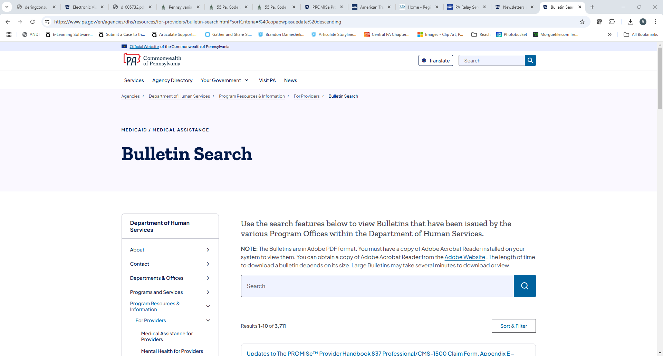

# [Publications Search](https://www.dhs.pa.gov/docs/Publications/Pages/default.aspx)

https://www.pa.gov/en/agencies/dhs/dhs-search/dhs-publications.html

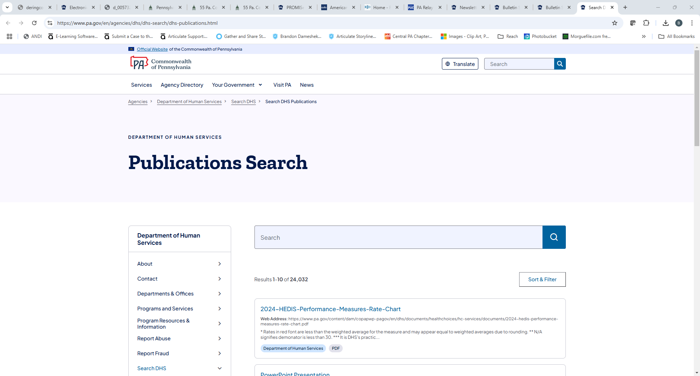

# [DHS Form Search](https://www.dhs.pa.gov/docs/Publications/Pages/Form-Search.aspx)

https://www.pa.gov/en/agencies/dhs/resources/for-providers/form-search.html

