**Community HealthChoices Resources**

Table of Contents

Department of Human Services 1

Department of Human Services (DHS) 1

Community HealthChoices (CHC) 1

CHC for Providers 1

CHC for Participants 1

Participant Call Center 1

Provider Call Center 1

PA Relay 1

CHC Fact Sheet 1

Adult Benefits Package 1

Information on Electronic Visit Verification (EVV) system 1

Information about Cost of Care – OIM Long-Term Care Handbook Chapter 468: 468.3 Payment Toward the Cost of LTC Facility Services- Step 2 1

MLTSS Subcommittee 2

NHT Helpline 2

Managed Care Organizations 3

AmeriHealth Caritas Pennsylvania (Keystone First in the Southeast) 3

Keystone First 3

PA Health & Wellness 3

UPMC Community HealthChoices 3

PA Independent Enrollment Broker 4

ListServs, Forms, Bulletins, Alternatives to Nursing Homes, and Quick Tips 5

ListServs 5

Department of Human Services List Archives 6

DHS Form Search 8

Bulletin Search 9

Alternatives to Nursing Homes (HCBS Waiver Services) 10

Quick Tips for Medicaid Providers 11

# Department of Human Services

## [Department of Human Services (DHS)](https://www.pa.gov/en/agencies/dhs.html)

https://www.pa.gov/en/agencies/dhs.html

## [Community HealthChoices (CHC)](https://www.pa.gov/en/agencies/dhs/resources/medicaid/chc.html)

https://www.pa.gov/en/agencies/dhs/resources/medicaid/chc.html

## [CHC for Providers](https://www.pa.gov/en/agencies/dhs/resources/medicaid/chc/chc-providers.html)

https://www.pa.gov/en/agencies/dhs/resources/medicaid/chc/chc-providers.html

## [CHC for Participants](https://www.pa.gov/en/agencies/dhs/resources/medicaid/chc.html)

https://www.pa.gov/en/agencies/dhs/resources/medicaid/chc.html

## Participant Call Center

800-757-5042

## Provider Call Center

800-938-0939

## PA Relay

Dial 711

## [CHC Fact Sheet](https://www.pa.gov/content/dam/copapwp-pagov/en/dhs/documents/healthchoices/hc-services/documents/CHC%20Fact%20Sheet.pdf)

https://www.pa.gov/content/dam/copapwp-pagov/en/dhs/documents/healthchoices/hc-services/documents/CHC%20Fact%20Sheet.pdf

## [Adult Benefits Package](https://www.pa.gov/content/dam/copapwp-pagov/en/dhs/documents/healthchoices/hc-services/documents/Adults%20Benefits%20Package.pdf)

https://www.pa.gov/content/dam/copapwp-pagov/en/dhs/documents/healthchoices/hc-services/documents/Adults%20Benefits%20Package.pdf

## [Information on Electronic Visit Verification (EVV) system](https://www.pa.gov/en/agencies/dhs/resources/for-providers/evv.html)

https://www.pa.gov/en/agencies/dhs/resources/for-providers/evv.html

## [Information about Cost of Care – OIM Long-Term Care Handbook Chapter 468: 468.3 Payment Toward the Cost of LTC Facility Services- Step 2](http://services.dpw.state.pa.us/oimpolicymanuals/ltc/index.htm#t=468_Eligibility_and_Payment%2F468_3_Step2_Pmt_toward_LTC_Facility_Srvs.htm)

http://services.dpw.state.pa.us/oimpolicymanuals/ltc/index.htm#t=468_Eligibility_and_Payment%2F468_3_Step2_Pmt_toward_LTC_Facility_Srvs.htm

[***Medical Assistance Advisory Committee (MAAC)***](https://www.pa.gov/en/agencies/dhs/about/councils-committees/maac.html)

https://www.pa.gov/en/agencies/dhs/about/councils-committees/maac.html

## [MLTSS Subcommittee](https://www.pa.gov/en/agencies/dhs/about/councils-committees/managed-long-term-subcommittee.html)

https://www.pa.gov/en/agencies/dhs/about/councils-committees/managed-long-term-subcommittee.html

## NHT Helpline

800-833-5196

# Managed Care Organizations

## [AmeriHealth Caritas Pennsylvania](https://www.amerihealthcaritaschc.com/) (Keystone First in the Southeast)

https://www.amerihealthcaritaschc.com/

Participant Services: 1-855-235-5115 (TTY 1-800-235-5112)

Provider Services: 1-800-521-6007

Email: providercommunicationschc@amerihealthcaritas.com

## [Keystone First](https://www.keystonefirstchc.com/index.aspx)

https://www.keystonefirstchc.com/index.aspx

Participant Services: 1-855-332-0729 (TTY 1-855-235-4976)

Provider Services: 1-800-521-6007

Email: Long-term Services and Supports (LTSS) Providers: chcproviders@keystonefirstchc.com

## [PA Health & Wellness](https://www.pahealthwellness.com/)

https://www.pahealthwellness.com/

Phone: 1-844-626-6813 (TTY 1-844-349-8916)

Submit inquiries through this [contact form](https://www.pahealthwellness.com/contact-us.html) (https://www.pahealthwellness.com/contact-us.html)

## [UPMC Community HealthChoices](https://chc.upmchealthplan.com/)

https://chc.upmchealthplan.com/

Participant Services: 1-844-833-0523 (TTY 711)

Email: chc@upmc.edu

# [PA Independent Enrollment Broker](https://paieb.com/en)

https://paieb.com/en

* On this webpage you can select “Apply” to apply for Long Term Services and Supports (LTSS) Waiver services.
* On this webpage you can select “Contact us” and then select “referral form” to apply for Home and Community Based Services or to contact the PA Independent Enrollment Broker.

**By telephone**

Call the PA CHC Helpline at 1-844-824-3655 (TTY: 711)

We are open Monday through Friday, 8:00 a.m. to 6:00 p.m.

**By Mail**

PA IEB

P.O. Box 61560

Harrisburg PA 17106

# ListServs, Forms, Bulletins, Alternatives to Nursing Homes, and Quick Tips

## ListServs

Documents are issued through the program office ListServ and posted to state websites.

The DHS listServs can be accessed through the [Online Services page](https://www.pa.gov/en/agencies/dhs/contact/newsletters-listservs.html) at https://www.pa.gov/en/agencies/dhs/contact/newsletters-listservs.html.

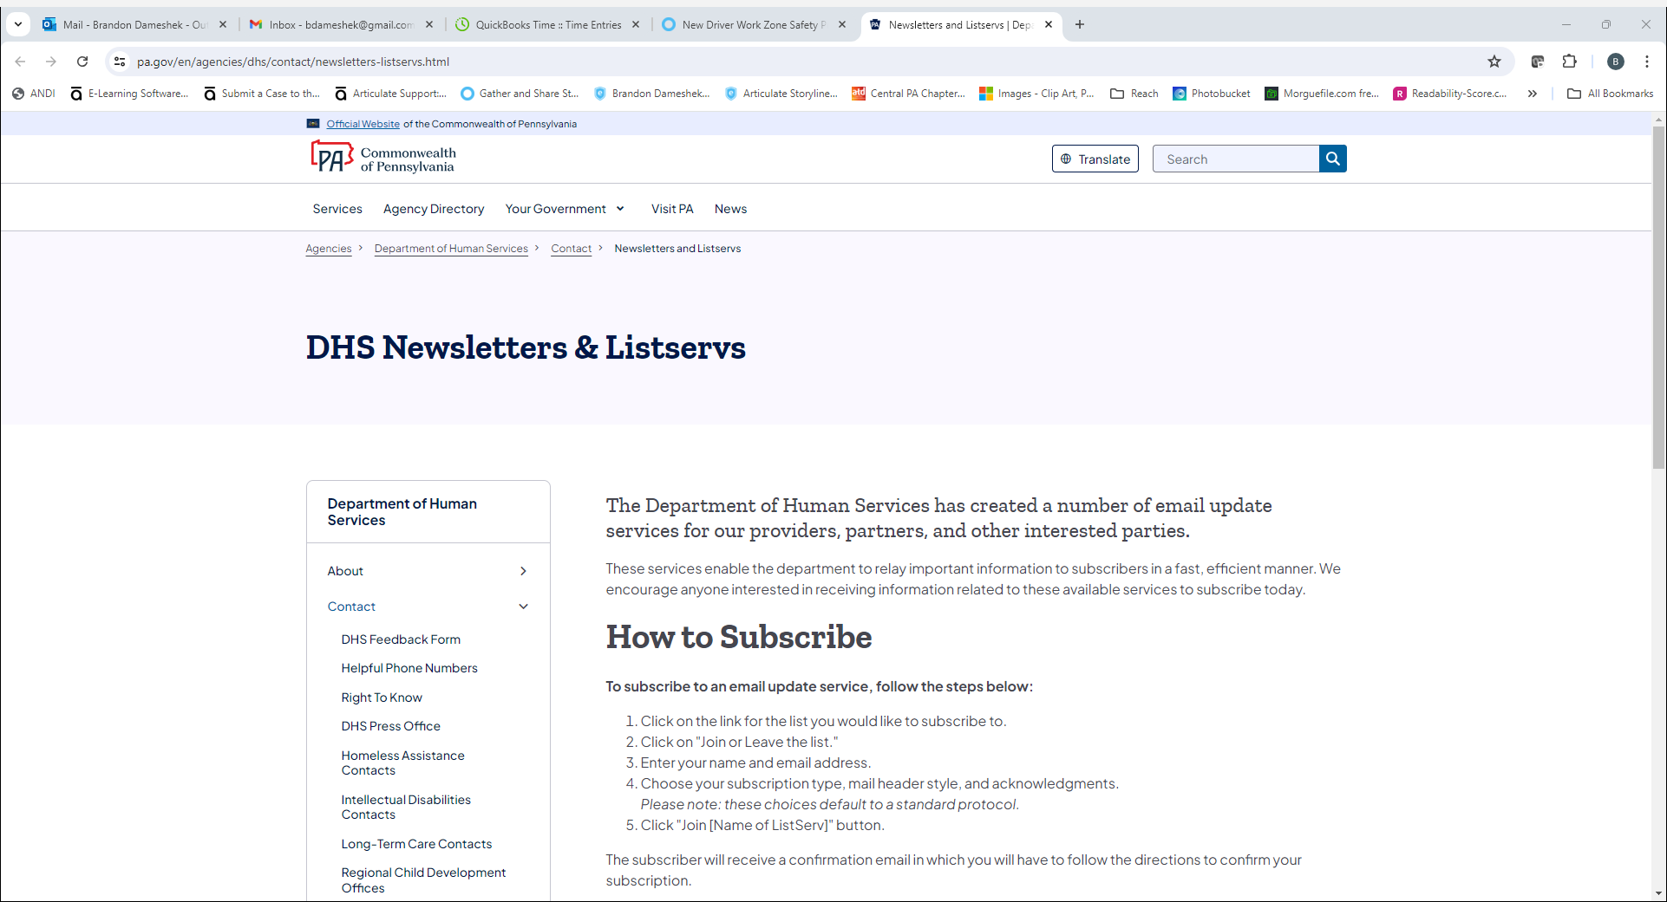

## [Department of Human Services List Archives](http://listserv.dhs.pa.gov/)

http://listserv.dhs.pa.gov/

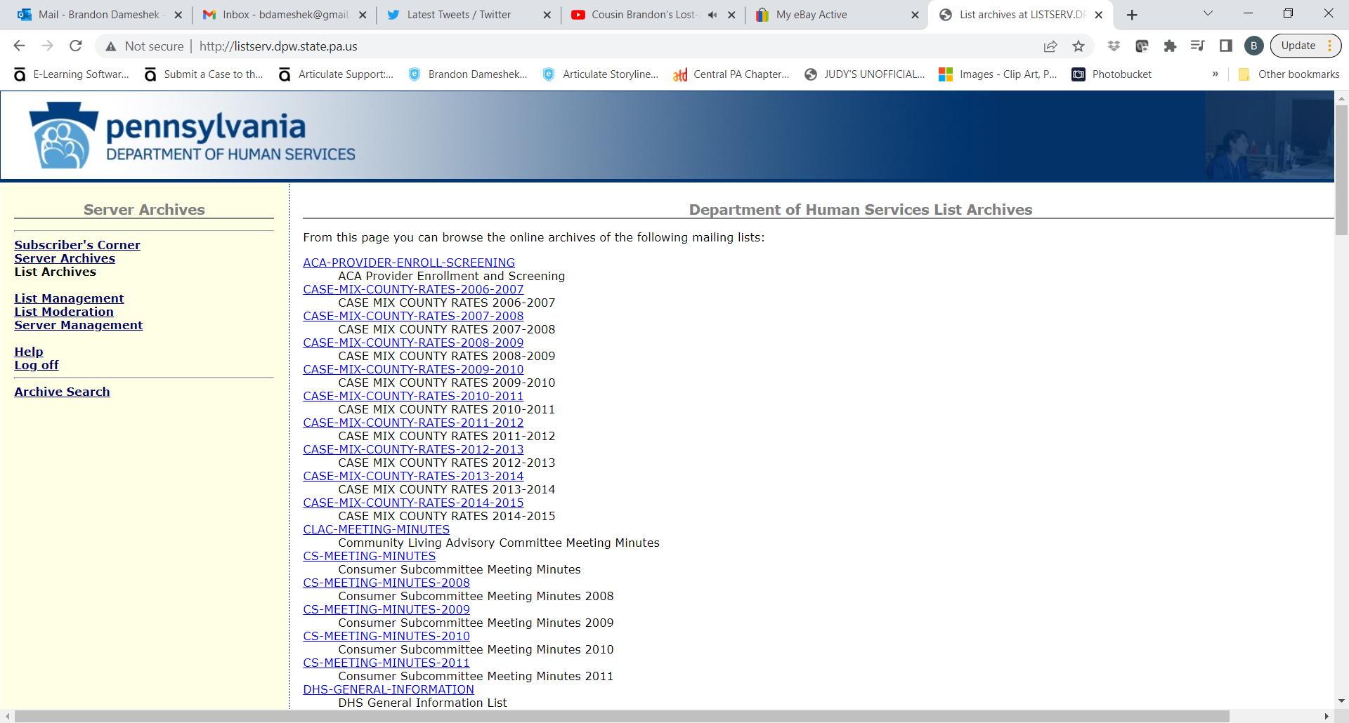

[MLTSS-MEETING-MINUTES](http://listserv.dhs.pa.gov/mltss-meeting-minutes.html)

http://listserv.dhs.pa.gov/mltss-meeting-minutes.html

Managed Long Term Services and Supports Subcommittee

[OLTL-COMMUNITY-HEALTHCHOICES](http://listserv.dhs.pa.gov/oltl-community-healthchoices.html)

http://listserv.dhs.pa.gov/oltl-community-healthchoices.html

OLTL Community HealthChoices

[OLTL-SERVICE-COORDINATORS](http://listserv.dhs.pa.gov/oltl-service-coordinators.html)

http://listserv.dhs.pa.gov/oltl-service-coordinators.html

OLTL Service Coordinators

[OLTL-PA-LIFE-PRVDRS](http://listserv.dhs.pa.gov/oltl-pa-life-prvdrs.html)

http://listserv.dhs.pa.gov/oltl-pa-life-prvdrs.html

OLTL PA Life Providers

[HOME-COMMUNITY-WAIVER-PRVDRS](http://listserv.dhs.pa.gov/home-community-waiver-prvdrs.html)

http://listserv.dhs.pa.gov/home-community-waiver-prvdrs.html

OLTL Home Community Waiver Providers

[OLTL-NURSING-FACILITIES](http://listserv.dhs.pa.gov/oltl-nursing-facilities.html)

http://listserv.dhs.pa.gov/oltl-nursing-facilities.html

OLTL Nursing Facilities

[DHS-STAKEHOLDERS](http://listserv.dhs.pa.gov/dhs-stakeholders.html)

http://listserv.dhs.pa.gov/dhs-stakeholders.html

DHS Stakeholders

After you select the ListServ, click on the second bullet point, “Join or leave the list (or change settings).” Then enter your name, email address and click the Subscribe button. You will receive an email asking you to confirm the registration. You must confirm to be successfully registered for the ListServ.

## [DHS Form Search](https://www.pa.gov/en/agencies/dhs/resources/for-providers/form-search.html)

https://www.pa.gov/en/agencies/dhs/resources/for-providers/form-search.html

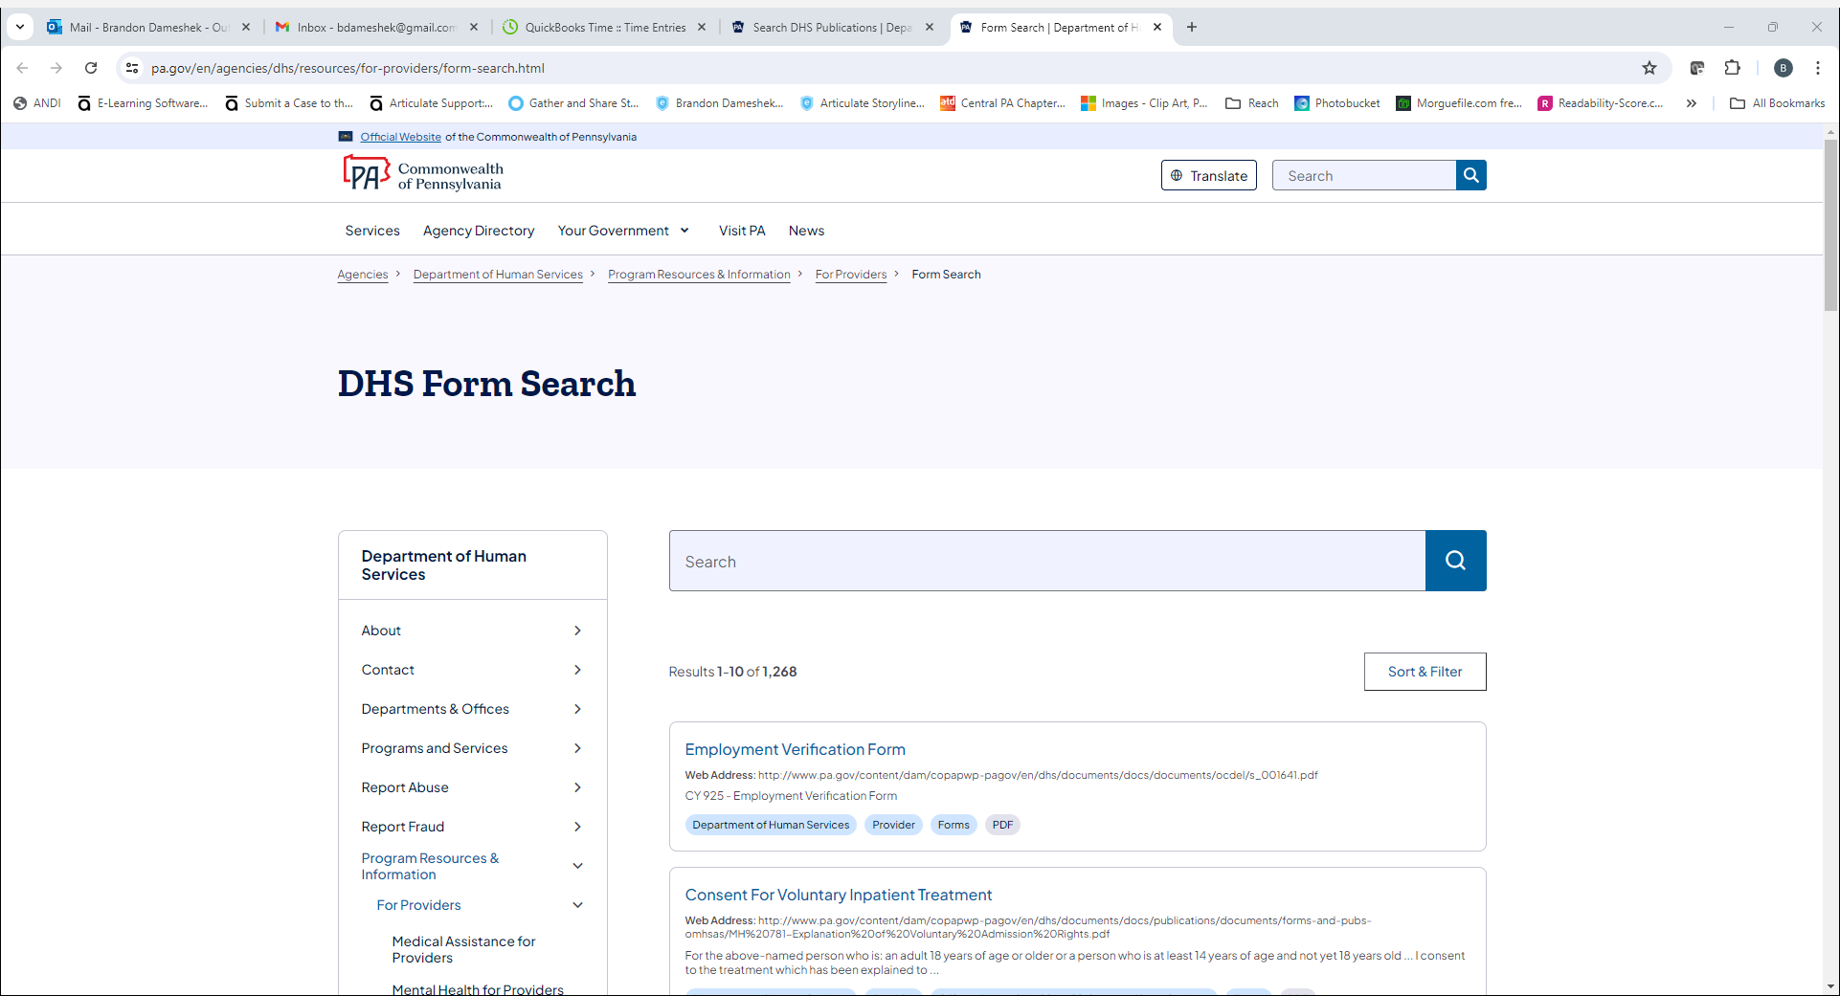

**2**

## [Bulletin Search](http://www.pa.gov/en/agencies/dhs/resources/for-providers/bulletin-search.html" \l "sortCriteria=%40copapwpdate%20descending)

www.pa.gov/en/agencies/dhs/resources/for-providers/bulletin-search.html#sortCriteria=%40copapwpdate%20descending

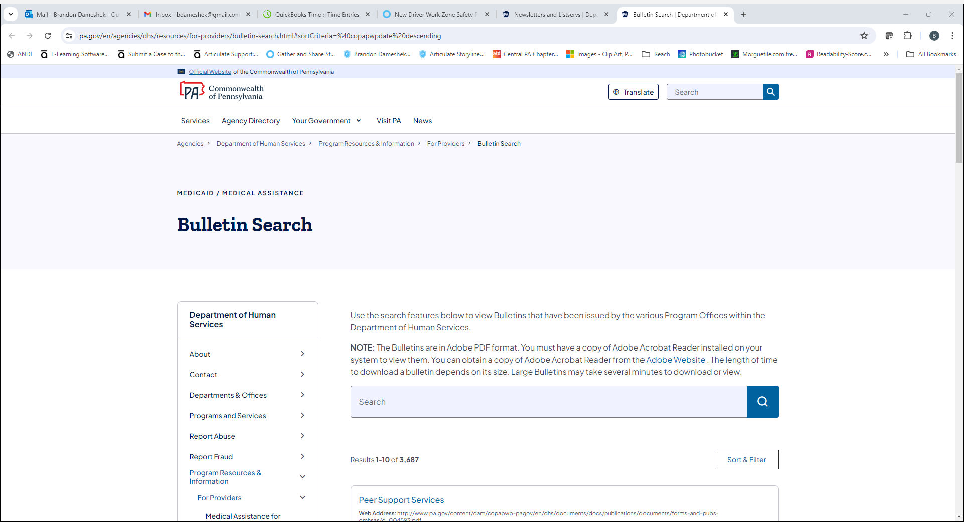

## [Alternatives to Nursing Homes](https://www.pa.gov/en/agencies/dhs/resources/aging-physical-disabilities/alternatives-to-nursing-homes.html) (HCBS Waiver Services)

https://www.pa.gov/en/agencies/dhs/resources/aging-physical-disabilities/alternatives-to-nursing-homes.html

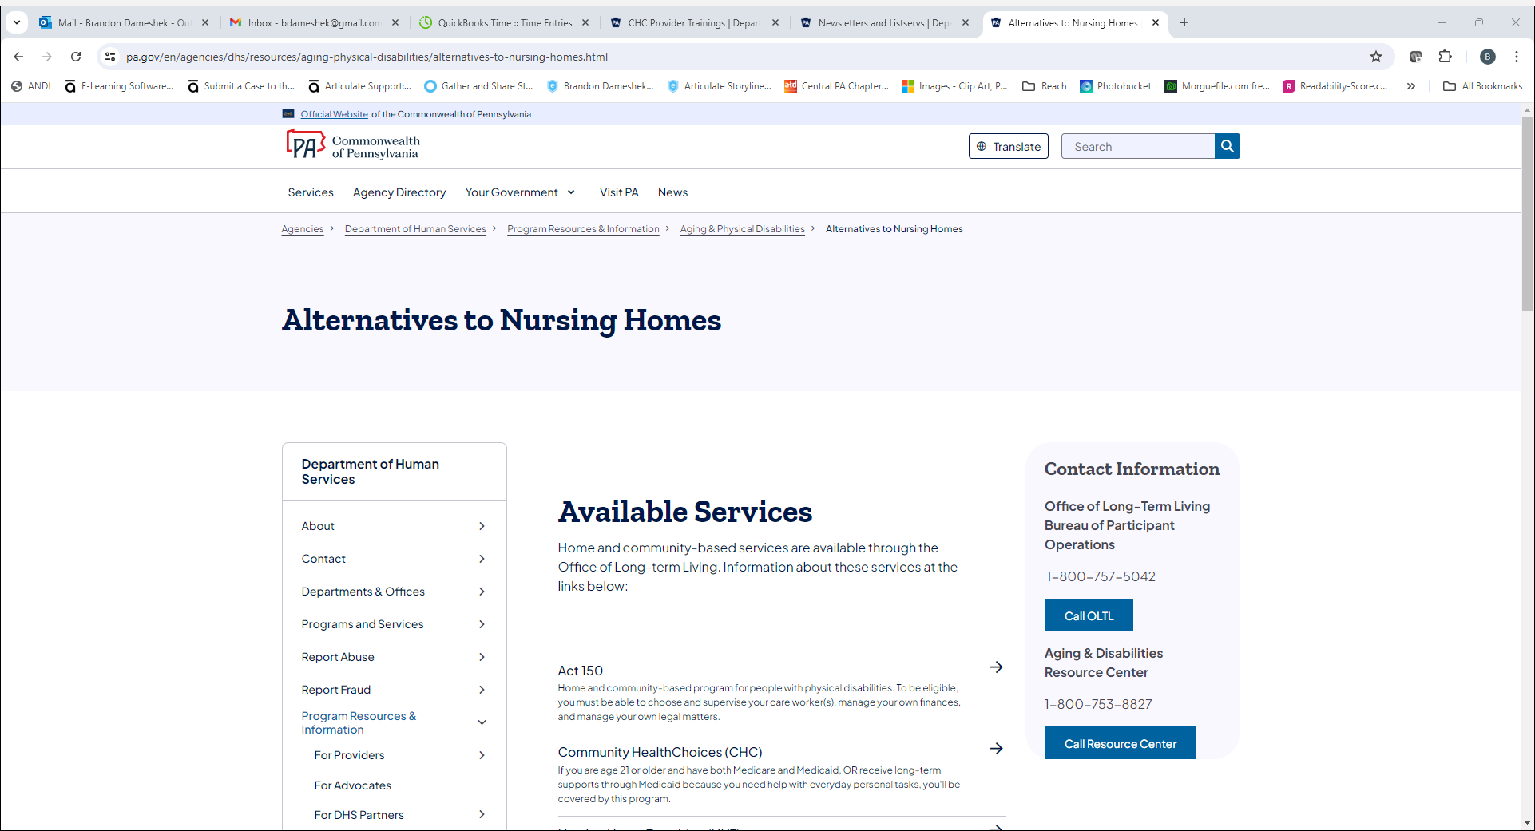

## [Quick Tips for Medicaid Providers](https://www.pa.gov/en/agencies/dhs/resources/for-providers/providers-quick-tips.html)

https://www.pa.gov/en/agencies/dhs/resources/for-providers/providers-quick-tips.html

