Provider Resources

Table of Contents
Module 1: Introduction to Long-term Care 1
Bureau of Fee-for-Service Programs 1
Community HealthChoices Provider Resources 1
Independent Enrollment Broker (IEB) 1
IEB Helpline 1
OLTL Participant Helpline 1
Participant Information Packet 1
PA Link to Aging and Disability Resources 1
Provider Enrollment Information 2
Waiver Descriptions 2
Module 2: Provider Responsibilities 2
DHS Training for Providers 2
Incident Management and Protective Services Online Training 2
Electronic Visit Verification 2
MA Bulletin 99-11-05 2
Pa Code 2
55 Pa Code § 52.20 2
55 Pa Code § 52.25 2
PROMISe Provider Education and Training 2
American Translators Association 2
Registry of Interpreters for the Deaf 3
PA Relay Services 3
DHS ListServs 4
Bulletin Search 5
Publications Search 8
DHS Form Search 9

Module 1: Introduction to Long-term Care

Bureau of Fee-for-Service Programs
https://www.dhs.pa.gov/contact/DHS-Offices/Pages/OMAP-Bureau%20of%20Fee-For-Service%20Programs.aspx
Office of Long-Term Living (OLTL) Provider Call Center
Toll free: 1-800-932-0939
Mon – Thurs, 9:00 am to 12:00 pm and 1:00 pm to 4:00 pm
Option 1: Provider Enrollment
Option 2: Billing and Claims
Option 3: Nursing Home Transition
Email for billing and claims: RA-ProviderOperation@pa.gov
Email Enrollment section: RA-HCBSEnProv@pa.gov
Fax: (717) 772-0965

Community HealthChoices Provider Resources
https://www.dhs.pa.gov/HealthChoices/HC-Providers/Pages/CHCProvider-Main.aspx

Independent Enrollment Broker (IEB)
https://www.dhs.pa.gov/Services/Disabilities-Aging/Pages/Independent-Enrollment-Broker.aspx

IEB Helpline
Toll Free: 1-877-550-4227

OLTL Participant Helpline
Toll Free: 1-800-757-5042

Participant Information Packet
https://www.dhs.pa.gov/Services/Disabilities-Aging/Documents/Long-Term%20Care%20Services/Participant%20Information%20Packet.PDF
The Participant Information Packet is available in several languages on the Long-Term Care Services webpage.
https://www.dhs.pa.gov/Services/Disabilities-Aging/Pages/Long-Term-Care-Services.aspx

PA Link to Aging and Disability Resources
http://www.aging.pa.gov/local-resources/pa-link/Pages/default.aspx
Toll free: 1-800-753-8827

Provider Enrollment Information
https://www.dhs.pa.gov/providers/Providers/Pages/PROMISe-Enrollment.aspx

Waiver Descriptions
https://www.dhs.pa.gov/Services/Disabilities-Aging/Pages/Alternatives-to-Nursing-Homes.aspx

Module 2: Provider Responsibilities

DHS Training for Providers
https://www.dhs.pa.gov/providers/Pages/Trainings.aspx

Incident Management and Protective Services Online Training
https://deringconsulting.com/OLTL-Provider/

Electronic Visit Verification
https://www.dhs.pa.gov/providers/Billing-Info/Pages/EVV.aspx

MA Bulletin 99-11-05
Provider Screening of Employees and Contractors for Exclusion from Participation in Federal Health Care Programs and the Effect of Exclusion on Participation
https://www.dhs.pa.gov/docs/Publications/Documents/FORMS%20AND%20PUBS%20OMAP/d_005732.pdf

Pa Code
https://www.pacodeandbulletin.gov/

55 Pa Code § 52.20
http://www.pacodeandbulletin.gov/Display/pacode?file=/secure/pacode/data/055/chapter52/chap52toc.html&d=#52.20

55 Pa Code § 52.25
http://www.pacodeandbulletin.gov/Display/pacode?file=/secure/pacode/data/055/chapter52/chap52toc.html&d=#52.25.

PROMISe Provider Education and Training
https://www.dhs.pa.gov/providers/Providers/Pages/PROMISe-Provider-Education-Training.aspx

American Translators Association
https://www.atanet.org/

Registry of Interpreters for the Deaf
https://www.rid.org/

PA Relay Services
http://www.puc.pa.gov/consumer_info/telecommunications/pa_relay_services_.aspx

DHS ListServs
https://www.dhs.pa.gov/about/Pages/Listservs.aspx

To navigate from the DHS Homepage:
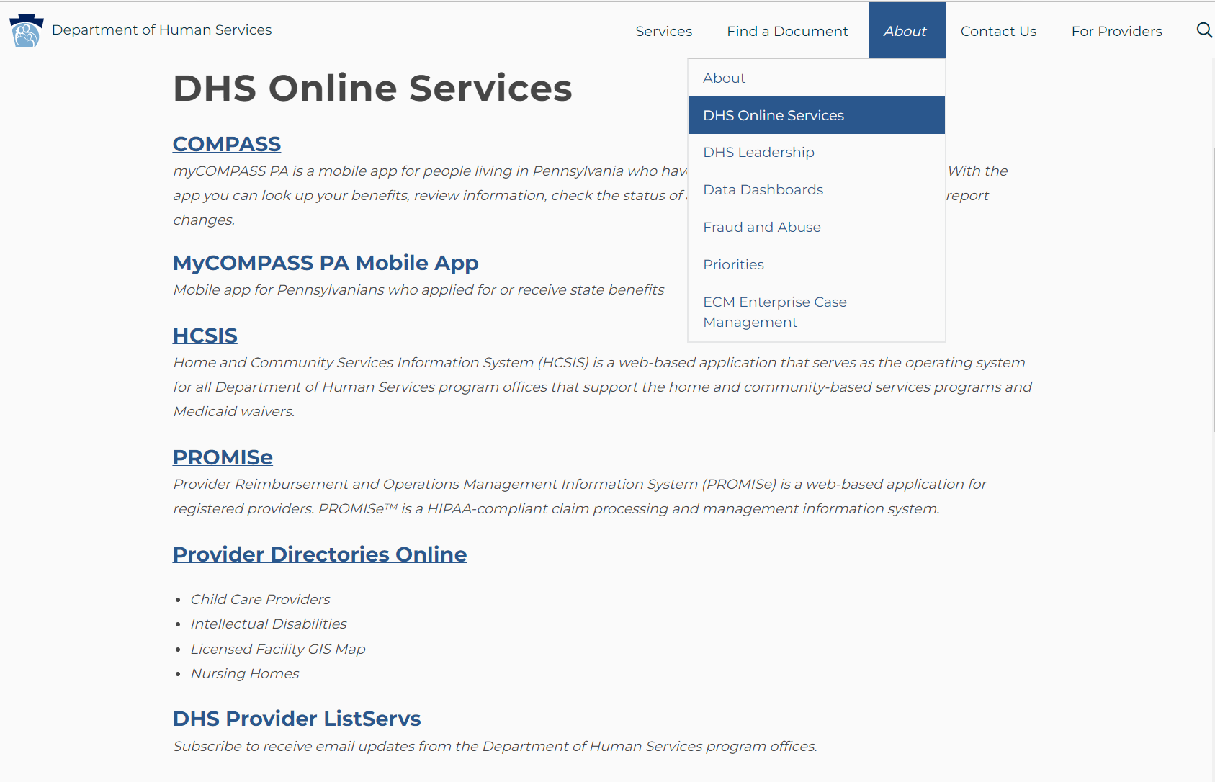
3
1
2

Bulletin Search
https://www.dhs.pa.gov/docs/Publications/Pages/default.aspx

To navigate from the DHS Homepage:
1
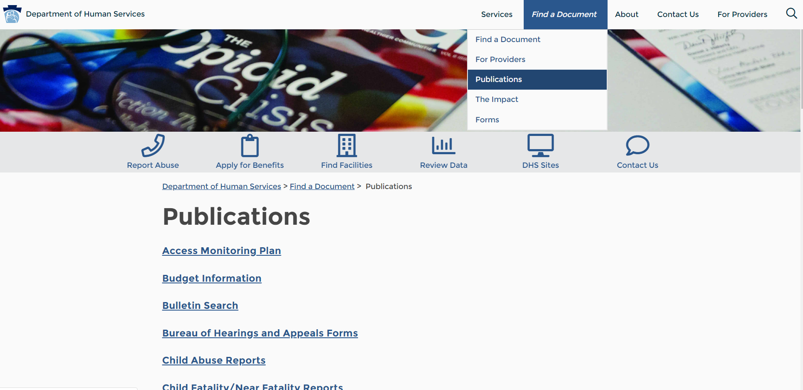
3
2

In addition, the Bulletin Search can be accessed directly at:
https://www.dhs.pa.gov/docs/For-Providers/Pages/Bulletin-Search.aspx

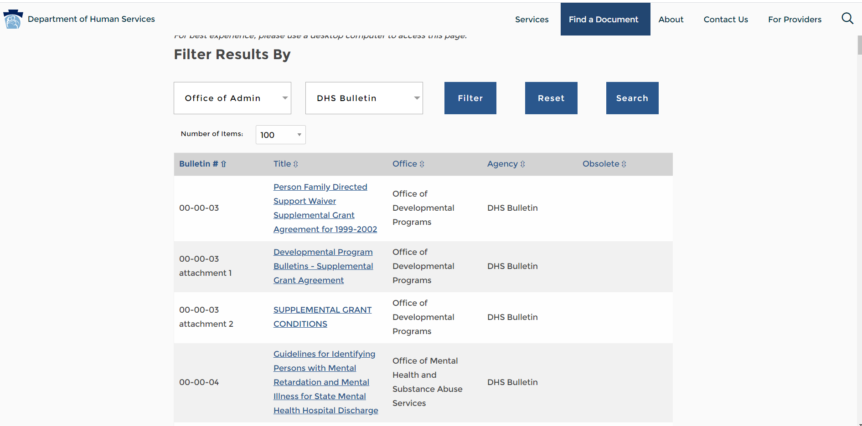

To make your bulletin search easier, follow these steps:

- In the first drop-down, choose the office(s) for which you want to find bulletins. A good choice for OLTL providers is the Office of Long-Term Living and Office of Medical Assistance Programs.

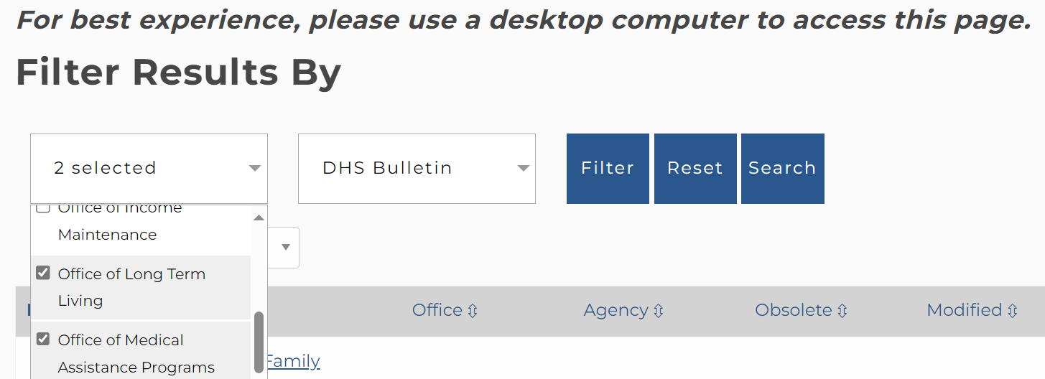

- Select Filter, which will bring up all bulletins for the office(s) chosen.

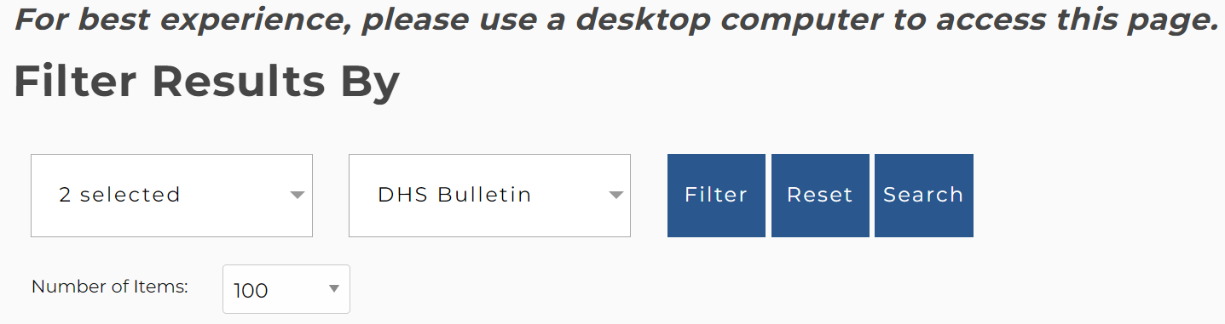

- Under Number of Items, choose “All” to bring up all bulletins for the office(s) chosen.

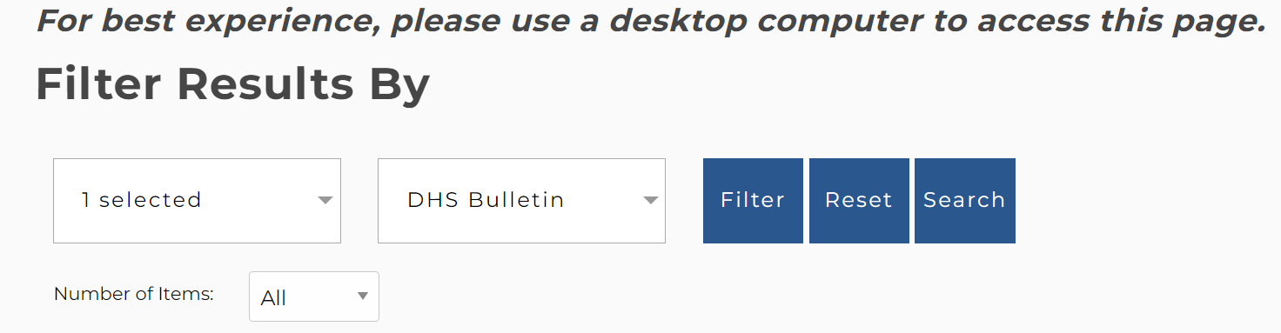

- Use the find function (ctrl + F) to search for the term you’re looking for:

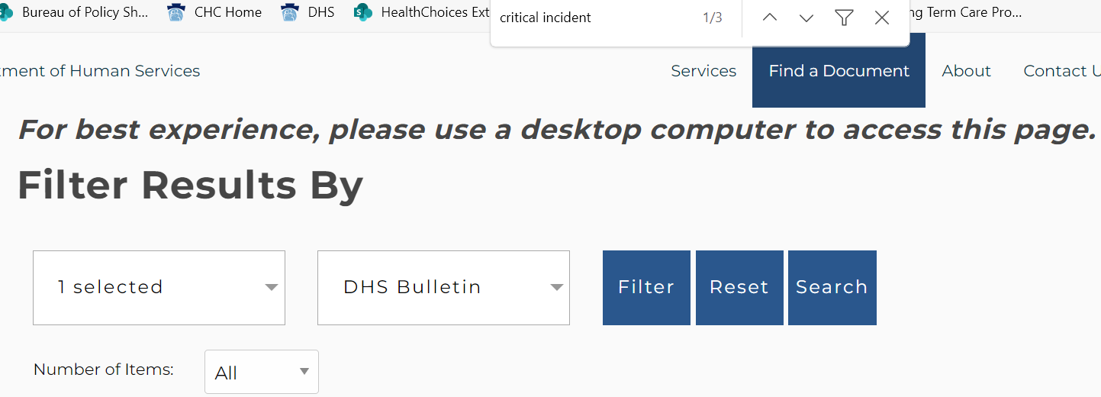

Publications Search
https://www.dhs.pa.gov/docs/Publications/Pages/default.aspx

To navigate from the DHS Homepage:
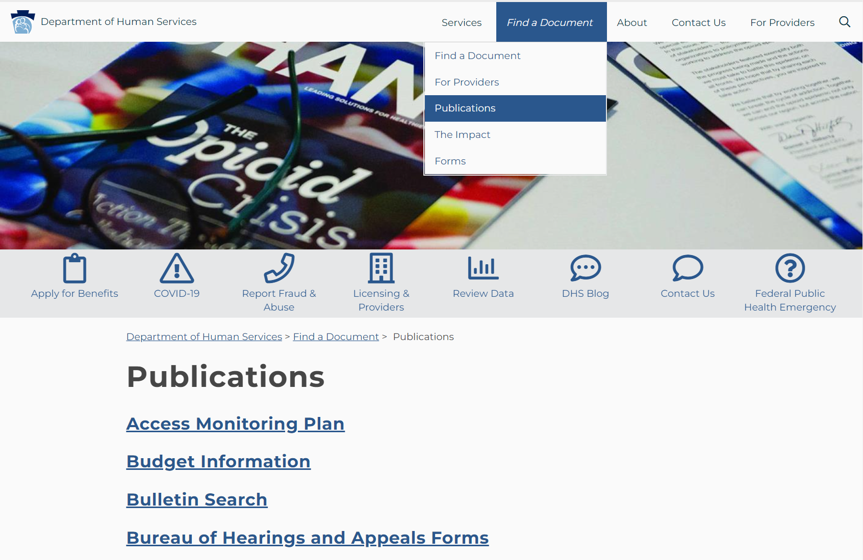
1
2

DHS Form Search
https://www.dhs.pa.gov/docs/Publications/Pages/Form-Search.aspx

To navigate from the DHS Homepage:
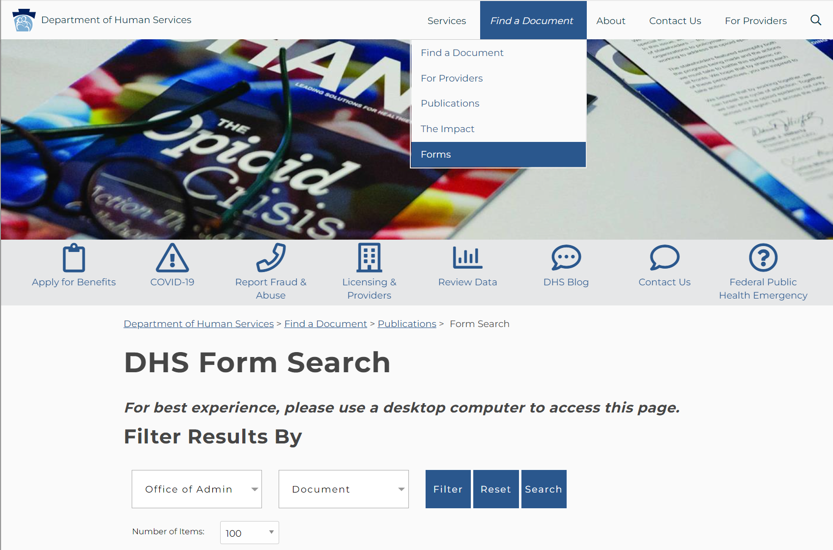
1
2

